User Guide 43 Key SPEAR screens
Purpose of this User Guide
The purpose of this User Guide is to explain the key SPEAR screens or tabs that a user has access to in SPEAR when viewing an application.
Who should read this?
Primary audience: All SPEAR users.
Introduction
SPEAR is a system that allows subdivision and planning permit applications to be compiled, lodged, managed, referred, approved and tracked online anytime.
SPEAR can be used by all parties involved in the subdivision and/or planning processes, but in differing capacities:
- Applicants use SPEAR to lodge and manage their application and track its progress,
- Responsible Authorities (councils) use SPEAR to receive, manage, refer and approve applications,
- Referral authorities use SPEAR to receive and respond to referrals,
- Members of the public can use SPEAR to find out basic information about an application and lodge and view objections.

All SPEAR users, regardless of their interest in an application have access to the same key SPEAR screens. The following SPEAR screens will be described in more detail in this guide:
  - Application List
  - Summary screen
  - Details screen
  - Contacts screen
  - Guests screen
  - Map View
  - Notes screen
43.1 Application List
The Application List displays all the SPEAR applications assigned to your organisation. This list is displayed when you first login to SPEAR. However, if you enter SPEAR via a hyperlink from a notification email you will bypass this screen. You can navigate back to the Application List from the Summary or Details screens by clicking on the Return to Application List link in the banner section of the screen.
The Application List will display applications in alphabetical/numerical order depending on the default sort order for each user. This can be modified from the user Settings link, located at the very top of the page. From the Setting page, scroll down to ‘SPEAR Settings’ and select an option under ‘Sort application list by’.
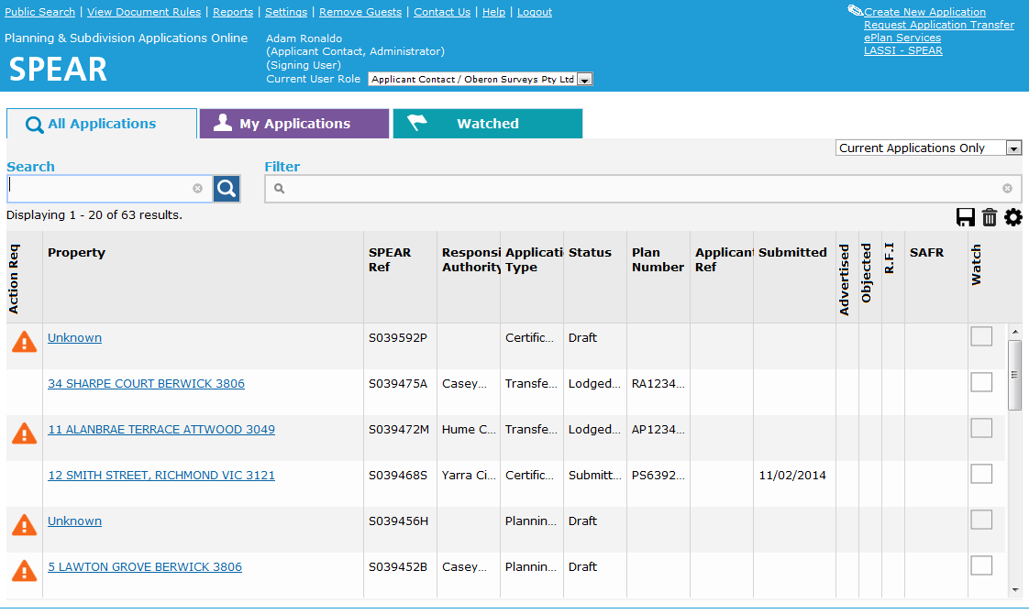
The information that will be displayed on this screen will depend on your organisation type. Below is an example of the screen displayed to an Applicant Contact organisation.

The list can be tailored to view ‘Current’, ‘Active’, ‘Completed’ and ‘All’ applications. Use the drop-down list in the right-hand corner of the table to apply this filter. These filters may change according to user role.

The column headings visible in the Application List will vary depending on your organisation type. All users will see a combination of columns, which are displayed based on default display settings for each user role.

The Application List can easily be customised by:
- Changing the order of the columns by clicking and dragging a column heading to the desired location
- Changing the width of the columns by clicking and dragging the column borders in and out
- Adding or removing columns in the list by clicking theicon
- Saving user preferences by clicking the icon.
- Restoring to the default view relevant to the organisation type by clicking theicon.
- Application List data can be exported to Excel using the icon.
Depending on the columns selected, and the filtering used to view applications, this export feature may have reporting / application tracking.

Adding or removing columns allows a user to access additional data fields that are available to view in the Application List. These include key decision dates, certification or SOC condition indicators, reference number fields, notes, number of lots, lodging party information etc.
Some data fields are mandatory for certain user roles (Applicant Contact, Responsible Authority, referral authority) as follows:
Action Req | Indication there are mandatory actions outstanding for the organisation to complete in that application. Click the exclamation mark for a quick summary of those actions.
Property | The property address for the application.
SPEAR# | A unique, SPEAR generated reference number allocated to all applications.
Watch | The ‘Watch’ feature allows a user to turn application watching on/off for each application. Watched applications will be depicted with a blue flag in the Watch column.  If an application is being watched, it will also appear on the Watched tab, and any email notifications that are generated by that application will also be copied to the watcher (in addition to the organisations SPEAR email).
Searching for applications from the Application List
Use the search and filter options at the top of the Application List to define search parameters to find specific applications.
The Search field is a free text field and performs a google type search on SPEAR applications. It allows searching on a wide range of data fields within applications including but not limited to:
- Full street address
- Estate name
- Plan number and stage number
- SPEAR reference
- Land description
- Applicant and Owner

To define your filter criteria, click in the filter field and select the filter type and criteria from the drop-down menus. To further refine the search, click in the field to the right of the last filter set and select the additional filter type and criteria. The Application List refreshes and applies new filters as they are set, and any matching results will appear in the list. To remove a filter, click the grey cross icon next to a filter. Alternatively, to clear all filters, click the grey cross right at the end of the field.
The columns in the Application List can be sorted. Click on column headings to sort the applications in alphabetical/numerical order. Clicking on the column again will reverse the order.
43.2 Summary screen
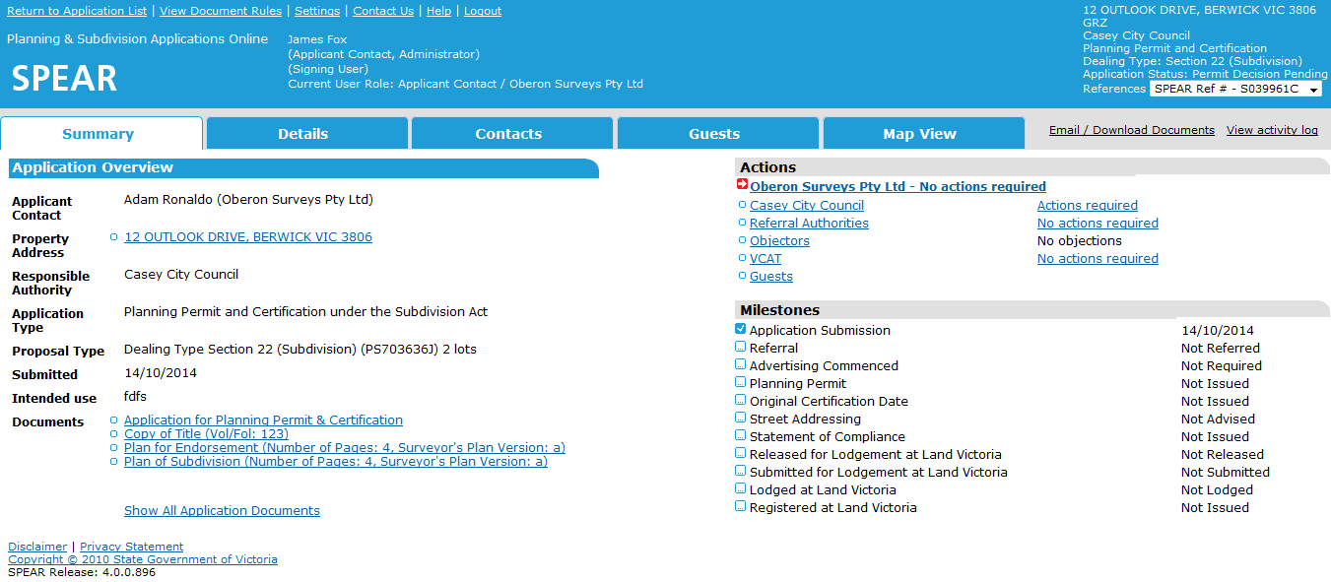
The Summary screen, accessed via the Summary tab, provides an overview of the application.

The left side of the screen provides details about the applicant, property address, type of application and information regarding the intended use of the property. At the bottom of this section are hyperlinks to some of the documents provided with the application. The documents listed will vary depending on the type of application, and local setting defined by the Responsible Authority.
The right side of the screen shows an Action and Milestones lists. The Action list displays the organisations involved in the application and whether they have actions outstanding. The Milestones list shows the key stages in the applications progression through the approval process. This list is automatically generated by SPEAR and will also show that an application is under advertisement or has a VCAT flag set.
A simplified version of the Summary screen may be displayed to a member of the public when using the public search function. If the application is advertised, the public can view the documents shown on this screen and will have an option (from the Summary screen) to register with SPEAR and lodge an online objection.
43.3 Details screen
The Details screen lists all existing documentation for an application and provides options from which a user can perform actions and attach documents to progress an application through the approval process.
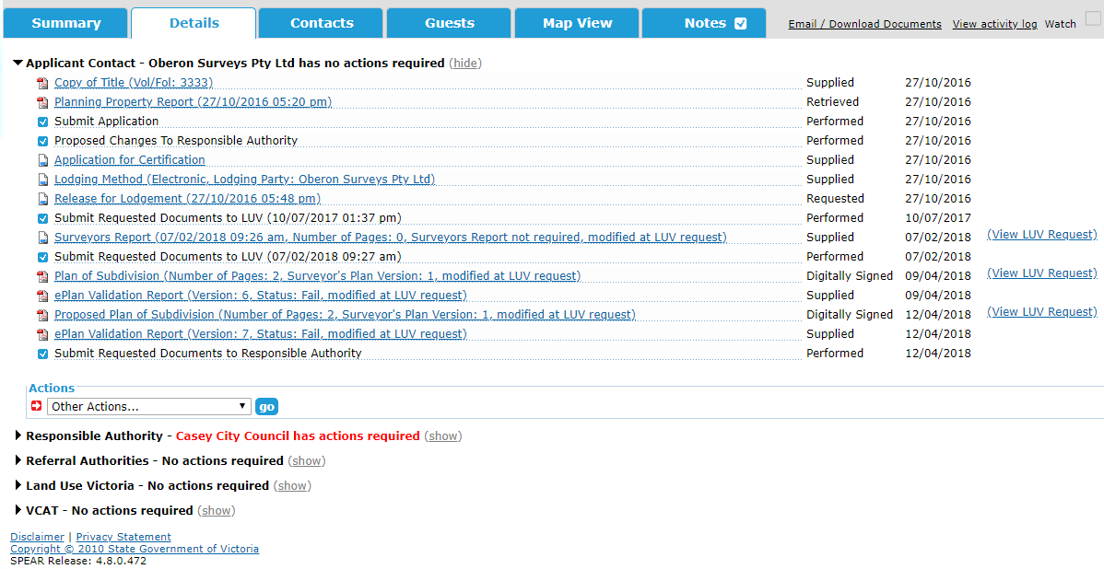
There are multiple sections on the Details screen e.g. Applicant Contact, Responsible Authority etc. Under each of these sections are the documents and actions completed by each organisation and an indication of the outstanding actions against an organisation (shown in black text with a ‘not supplied’ notation).
To view an organisation’s activity in an application, click on their organisation name heading and the view will be expanded (click again to hide the view).
Documents and actions will be shown under each organisation as a series of hyperlinks. To individually open and view these documents, click on the respective links, alternatively you can use the Email/Download Document link to open several documents at once.
For further information about the Email/Download Document Authentication, refer to User Guide 42 - Authentication – User Levels and Documents.
Completing actions in SPEAR from the Details screen: Mandatory Actions vs Optional Actions
Each organisation has actions that need to be carried out, so an application can progress. Actions are broken into categories – ‘mandatory’ or ‘optional’.
Mandatory Actions
Mandatory actions are ones that must be performed in an application. These actions occur when SPEAR recognises an action must be completed or another user requires additional information or actions to be undertaken.
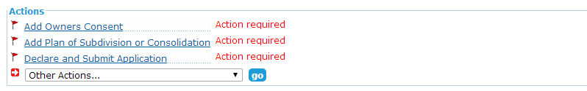
Mandatory actions will be displayed to a user in their organisation’s section of the Details screen under the Actions heading. Mandatory actions are flagged with a red flag icon and have the additional notation (shown in red) ‘Action required’. Clicking the Actions link will direct the user to a new page with the relevant options to complete that action.

Optional actions

Optional actions are additional steps you may want completed to support the application. Optional actions are found in the drop-down list headed ‘Other Actions…’. Select the action you wish to perform in the list and click ‘go’. This list will continuously change, depending on the application type and status.
NOTE: SPEAR will direct you to the relevant screen for that action. Complete the steps outlined on the screen and confirm. You will then be returned to the Details screen.
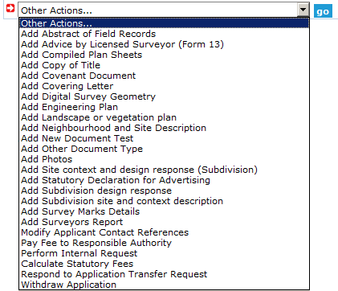

Modifying and deleting documents from the Details screen:
You can modify or delete documents added by your organisation from the Details screen of that application. Select either ‘modify’ or ‘delete’ in the corresponding drop-down box alongside the document and click ‘go’. Follow the on-screen instructions to complete the action.
NOTE: Some documents or actions cannot be changed or deleted once they have been authenticated; you can tell this by the absence of a drop-down box next to the document name.
Authenticating actions / documents
In most cases, when you complete an action or attach a document to an application in SPEAR, it will be necessary to approve (authenticate) this action. Authentication is completed from the Details screen.
For further information about Authentication, refer to User Guide 42 - User Authentication Levels and Document Authentication in SPEAR.
43.4 Contacts screen
The Contacts screen lists all interested parties who are involved in processing an application and their contact information. This is a useful screen if you need to contact someone in relation to a specific SPEAR application.
43.5 Guests screen
Applicant Contacts can grant guest access to third parties from the Guests screen. Whilst the guest cannot upload any documents in SPEAR, they will have access to view all documents within that application, including those added by the Responsible Authority and referral authorities. Guests can add comments to the Manage Conditions document and pay fees to Responsible Authorities that accept SPEAR Payments.
Other users can view a list of guests that have been invited by the Applicant Contact to view an application by clicking on the Guests tab within that application.

For further information about guest access, please refer to User Guide 39 - Guest access to SPEAR applications.
43.6 Map View screen
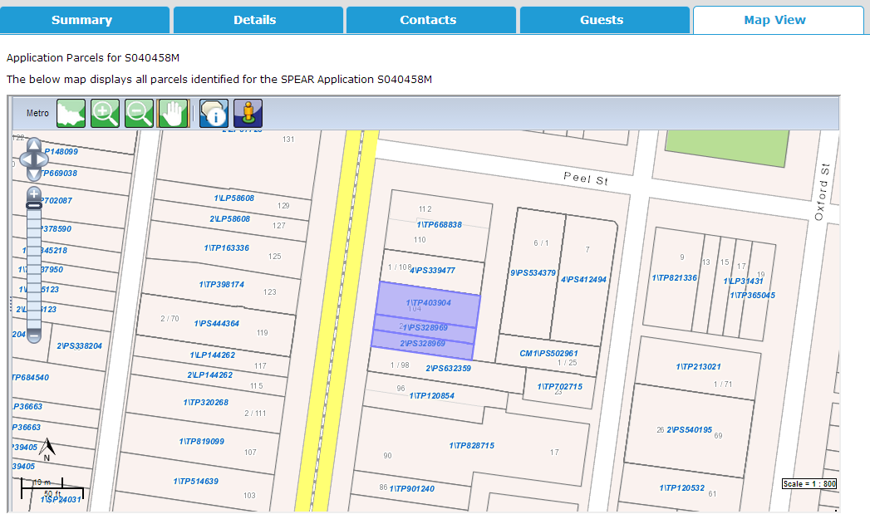All users can view the parcels associated with a SPEAR application by clicking on the Map View tab.

43.7 Notes tab
The Notes tab provides an internal method of communication within an organisation. The comments added in this section are intended to be informal communications, much like memo notes on a paper file.
All users within an organisation can view file notes that have been added by other users at the same organisation. Most users (except those with ‘view only’ access) can add notes.
There is also an option to select one or more users from the ‘Optional – Select one or more users to notify’ drop-down box, which will notify other users within the organisation via email when a new note has been added.
NOTE: Responsible Authorities with internal referral authorities can view each other’s file notes.
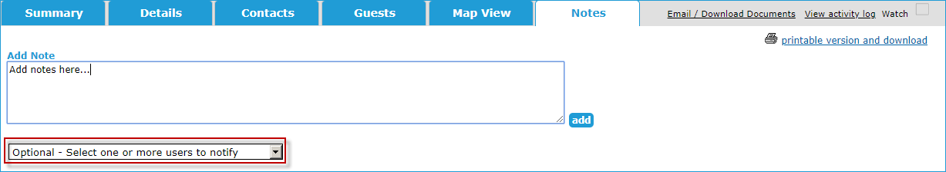

When a new note has been added that you haven’t seen, the Notes tab will appear with a red tick:
When a note has been read or the last note was made by yourself, it will appear with a blue tick:

Users can easily identify applications that have new and existing notes from the Application List. Notes with a red tick indicate there is a new, unread note. Notes with a blue tick indicate there is an existing note, which has already been viewed.
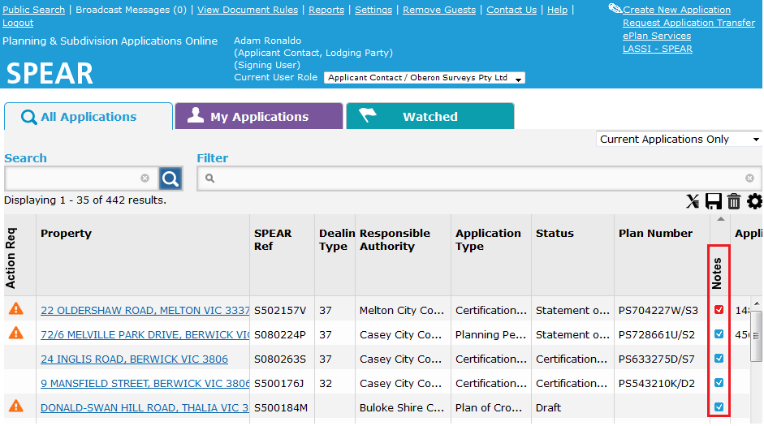

43.8 Soft logout
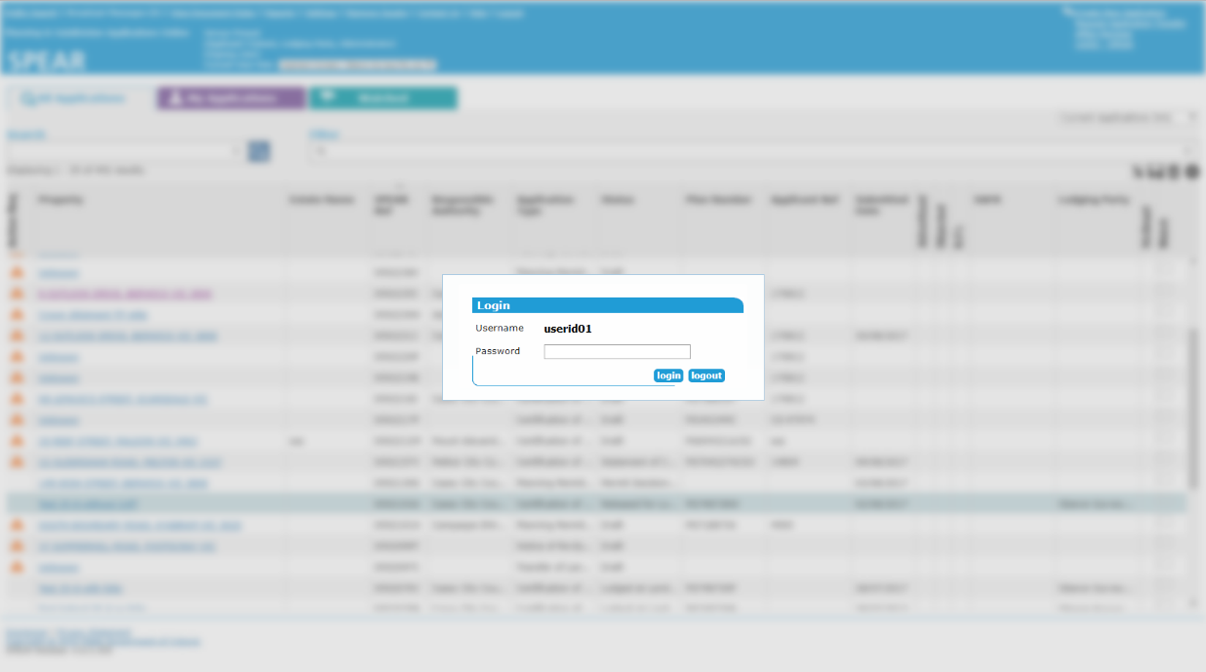
When a user is inactive in SPEAR for a period of 60 minutes, the system performs a soft logout. The SPEAR screen is obscured, and the user is prompted to enter their password to continue with their current session.
NOTE: After three failed password attempts, the session will be terminated, and the user will be returned to the Login screen.

If the current session is no longer required, users can select ‘logout’ to end the session.
Need more information?
Further information on this topic can be found by:
- Visiting the SPEAR website www.spear.land.vic.gov.au/SPEAR.
- Contacting the SPEAR Service Desk on 9194 0612 or email spear.info@delwp.vic.gov.au
- Selecting the Help link in the relevant area of the SPEAR system.

